Fusion Paranoia

Conspiracy podcast – Marketing analysis

20075914, 20076649, 20075687 & 20071864

2020

Table of Contents

[Nature of Business 2](#_Toc34817639)

[Products and Services 2](#_Toc34817640)

[Size of the company 2](#_Toc34817641)

[Location 3](#_Toc34817642)

[Origins of the company and successes 3](#_Toc34817643)

[Competitors in the marketplace 4](#_Toc34817644)

[Those Conspiracy Guys 4](#_Toc34817645)

[The truth is somewhere 4](#_Toc34817646)

[Conspiracy Theories 4](#_Toc34817647)

[Projected growth plans 5](#_Toc34817648)

[Marketing Campaign 6](#_Toc34817649)

[Goals and Objectives 6](#_Toc34817650)

[Our Survey 7](#_Toc34817651)

[Demographic 8](#_Toc34817652)

[Psychographics 9](#_Toc34817653)

[Behavioural 13](#_Toc34817654)

[Digital/Online Marketing Campaign 15](#_Toc34817655)

[Goals and objectives 15](#_Toc34817656)

[Developing our Image & brand 15](#_Toc34817657)

[Improvements on Website 16](#_Toc34817658)

[Content 16](#_Toc34817659)

[Email marketing strategy 17](#_Toc34817660)

[Search Engine Optimisation. 18](#_Toc34817661)

[Effectiveness of the Campaign 18](#_Toc34817662)

[References 22](#_Toc34817663)

# Nature of Business

The company proposed for this documentation is called Fusion Paranoia. This company will be a irish based conspiracy podcast based in Waterford in Ireland.

The name comes from a term coined by Michael Kelly in political convergence of left-wing and right-wing activists around anti-war issues and civil liberties, which he said were motivated by a shared belief in conspiracism or shared anti-government views.

# Products and Services

As this product is mainly a free podcast, the product is us for the time being. We will however be setting up merchandise such as T-shirts, Mugs, Badges, and Other accessories. As notes from our survey 31.4% of people said they would purchase Apparel, while 20% said they would purchase Posters or Prints.

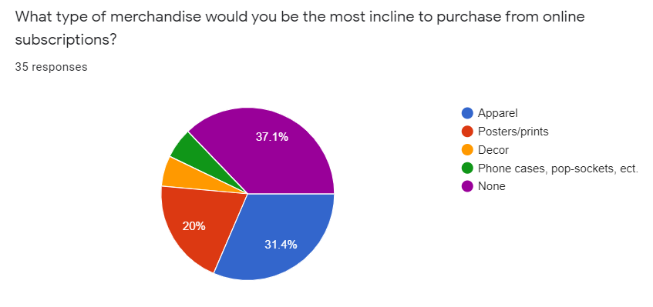As the company grows I’m sure we are to see these numbers increase but for the time being we are only limited to brand name, and not reputation or trust.

# Size of the company

As of now the company is a four people company with members taking turns with segments and information collection. Because of technological backgrounds, these members may also delve into tech support, online support, web building, and database housing all our information from past, present and future shows.

# Location

This company is based in 280 East Thorne Street, Waterford, Ireland (fake address), this will be our base of operations until revenue scaling allows us to expand to a more appropriate headquarters. As we will be using a €200 home recording studio setup for the time being.

Using these equipment we have turned one of the rooms into a makeshift recording studio with padded walls, tables and chairs along with a screen for presentation of idea’s once we delve into video recording and possibly incorporate a subscriber live cam or 3D camera for playback on YouTube and Facebook.

# Origins of the company and successes

Fusion Paranoia began back in 1964 a year after the JFK shooting, its original members consisted of a group of friends in their 30’s who decided to try find out what really happened with the shooter and the case. An illegal radio station was setup and broadcast in Manhattan May 13th, 1964 with the main goal of exposing the ludicracy and secrets hidden behind closed doors surrounding the case.

The station stayed on air for 10 years and had become largely known in the media as menaces who bring fear to those instead of closure. The station had up to 20,000 listeners daily and was surely growing steadily till the HQ was discovered and shut down by the local police. Four members of the group managed to flee as they were informed by a mole beforehand of the raid.

The group set off and hid in Canada as their names were unknown and eventually decided to jump continent to Ireland in 1984. Where they went on to have relatively regular lives and tried to leave their whistleblowing behind and have families.

The children of these read about the controversy regarding the take down, and decided it was about time to have another bout. It was officially set back up as a podcast legally in 2003.

# Competitors in the marketplace

Our competitors all have similar podcasts with similar content, but some of them have a different targeted audience.

Our main competitors are:

1. Those Conspiracy Guys
2. The truth is somewhere
3. Conspiracy theories

### Those Conspiracy Guys

[](https://www.youtube.com/user/thoseconspiracyguys/videos)Those conspiracy guys are an Irish podcast from Wicklow. They produce YouTube videos about related content and currently have 15’649 subscribers

Figure Those Conspiracy Guys Logo

Their about section explains: ‘Our aim is to cast a light into the dark corners of corruption, conspiracy and suppression

We want to scour a web laden with tales of political intrigue, extra-terrestrials, rogue governments secret societies, the paranormal, murder, mayhem, deceit, destruction, the cryptozoological and the psycho-pharma logical and present the fable of the 21st century: The Conspiracy Theory.’

### [C:\Users\JordanM\Desktop\TTIS.jpg](https://www.thetruthissomewhere.com/)The truth is somewhere

Figure ­­The truth is somewhere graphic

This is a relatively small podcast as their YouTube only has 9 subscribers, but they have 48,385 downloads on PodBean with 37 episodes recorded

‘The Truth Is Somewhere is a conspiracy theory and mystery discussion podcast run by a husband and wife team. Dark humour, junk science, real science, and some of the craziest stories the internet can come up with collide once a week.

### [C:\Users\JordanM\Desktop\475100_300x300.jpg](https://www.podbean.com/podcast-detail/3xbjg-73fdc/Conspiracy-Theories-Podcast)Conspiracy Theories

Figure Conspiracy Theories logo

This podcast has 6.0k followers with 27 episodes recorded on PodBean

‘The truth is rarely the best story. And when it’s not the only story, the truth deserves another look. Every Wednesday, we tell the complicated stories behind the world’s most controversial events and possible cover-ups. Conspiracy? Maybe. Coincidence? Maybe. Complicated? Absolutely. Conspiracy Theories is part of the Parcast Network and is a Cutler Media Production.’

# Projected growth plans

Within the next few years, we hope to move out of the house which is being rented currently and move to a larger facility capable of attending to our needs. We will try aim for better recording equipment and video equipment to allow our fan base to experience the podcast in a much more personal manner. This would help gain trust of the audience along with showing that we keep up with the current times and investigate the best ways to reach our market

The current staff is quite small, so eventually we hope to be able to hire more staff to help with maintenance, camera switching, social media outlets, Reddit pages, and scouring the web for relevant articles of use as everything is currently done by four people. This would also give us a little downtime to relax along with helping someone else pay their college tuition or as a fulltime job.

# Marketing Campaign

## Goals and Objectives

Our Market Campaign, is being planned and designed in order to spread the word about our business in the best possible light, but also without divulging any of the actual content so that we may draw in as many curious customers as possible and establish a wide, but loyal fan-base quickly.

We hope to appeal to our customers best nature and adapt their learning and educational methods to grain trust and loyalty in the community. As competition will be tight we hope to focus on making an appearance, and get used to the format before running an AD campaign.

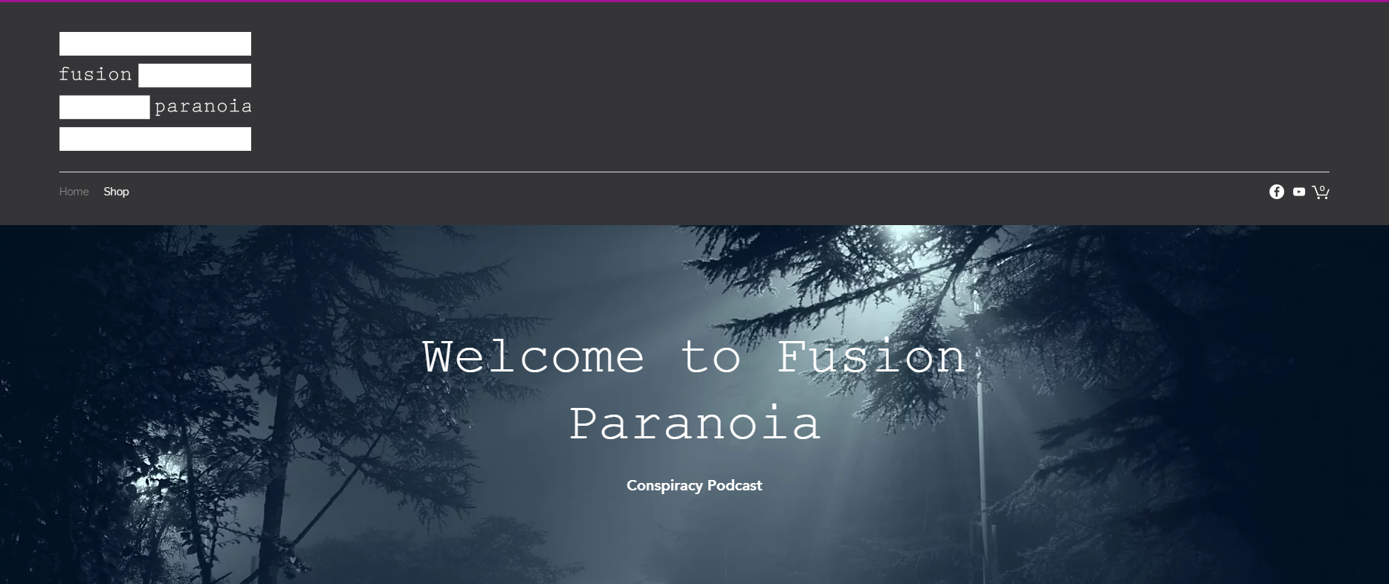

# Our Survey

When conducting our survey, we used our knowledge of market segmentation to structure it. We broke it into four segments to explore:

* Geographic
* Demographic
* Psychographic
* Behavioural

We decided to not focus on geographic as our streaming service, promotional offers and store are all online services that can be accessed anywhere with internet accessibility.

We wanted to put most of the focus towards Psychographics as although we wanted to express a need for identifying our market, we wanted to put our research towards understanding our market.

There was also a focus on our demographic and behavioural segments and have been categorised as so.

We posted the survey across our social media along with word of mouth and received 35 responses within the week so used this as our sample size.

# Demographic

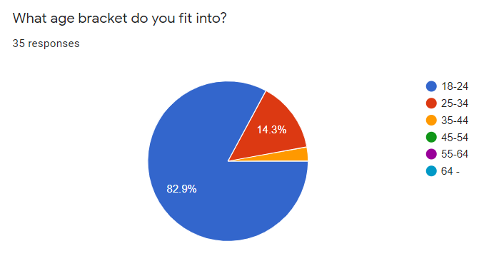Asking the age brackets determines a range of opinions based on the survey topic. For example, a person in their 60’s might answer differently to someone in their twenties. This helps gain a better understanding of their knowledge on the topic. Our sample seemed to be mainly 18-24 year olds.

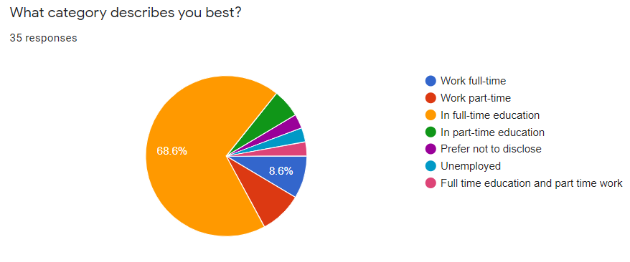

By getting an insight into the education/work of the participants, we can gain an understanding to the free time that someone would have to engage in online media content. Our sample held a majority of people in full-time education.

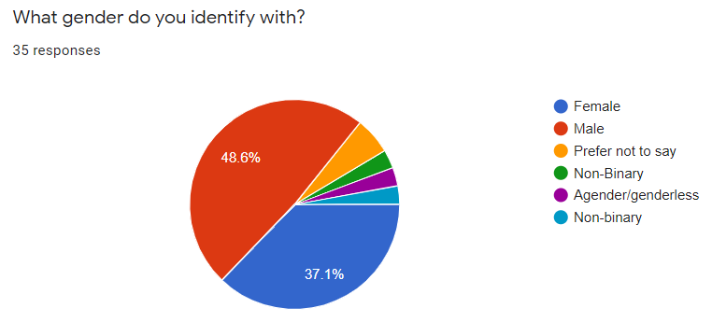Gender is often a standard demographic question. This information from the participants can improve marketing strategies by understanding who to cater to. Our sample was predominantly male but with a large contrast which we expected as we are aiming our brand as non-gender specific.

# Psychographics

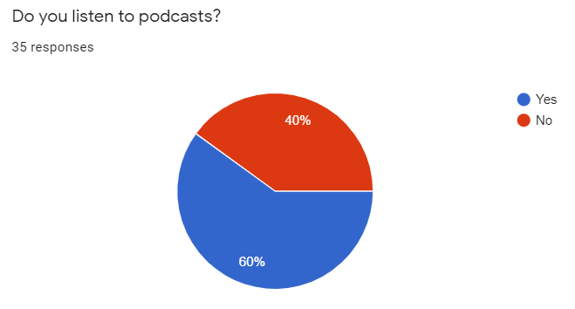This allows us to understand the best platform to produce content. For example, if the majority replied ‘No’ to this question, it would not be the best idea to use the platform as it wouldn’t be tailored to people’s preferences.

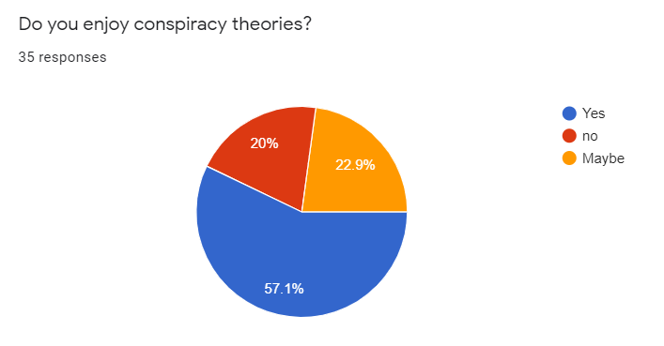As podcasts are still relatively new within the world of online streaming, it is important to get an insight into people’s understanding/use of these. By doing so, this allows us to consider whether podcasts would be the most suitable platform in which to deliver the content.

When tailoring content to a specific topic, we need to understand people’s enjoyment of it. This allows us to see whether the content would be enjoyed by the majority and if we have an audience big enough to market to.

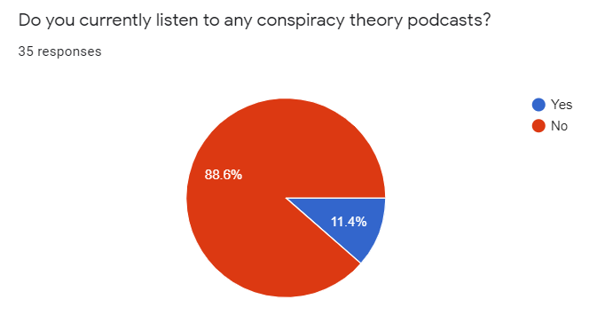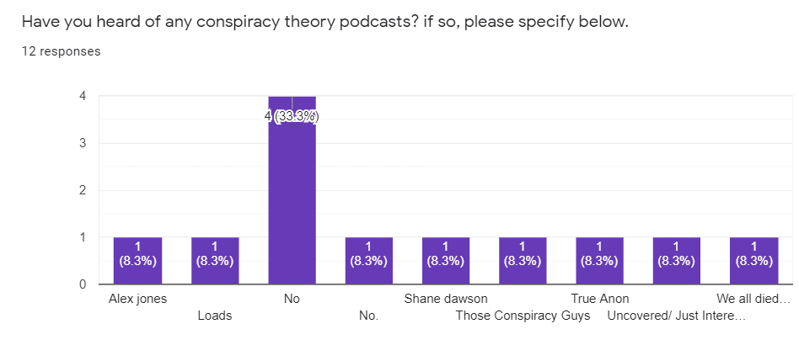This question shows the competitors within the market and the participants understanding of what’s available out there. By being aware of what’s on the market, we are able to look into the marketing strategies of other conspiracy theory podcasts and how they are tailoring their content to their audience.

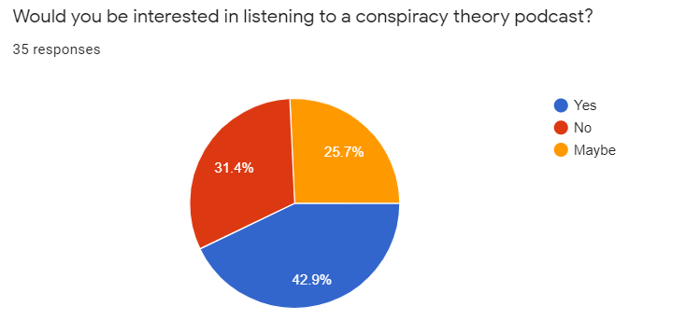The information provided to us from the participants within this question gives us a look into whether people are availing of the content made free to them on streaming platforms.

Now that we have an understanding of the percentage of those who are availing of podcasts, we know need to ask a question specifically related to conspiracy theories, to see if there is an interest amongst listening to a conspiracy podcast rather than any of the other topics available.

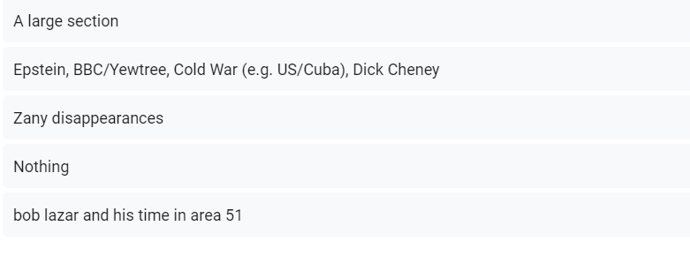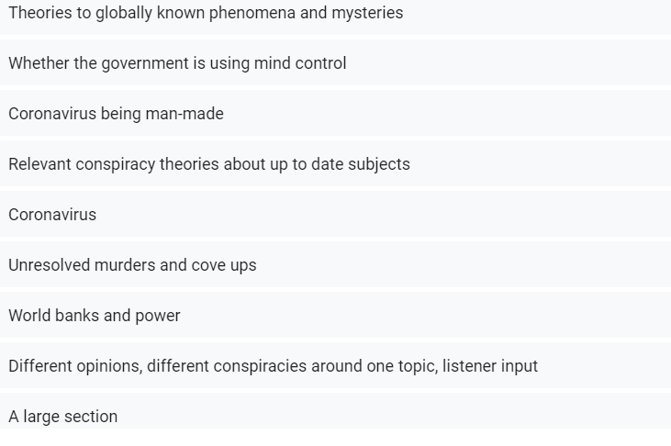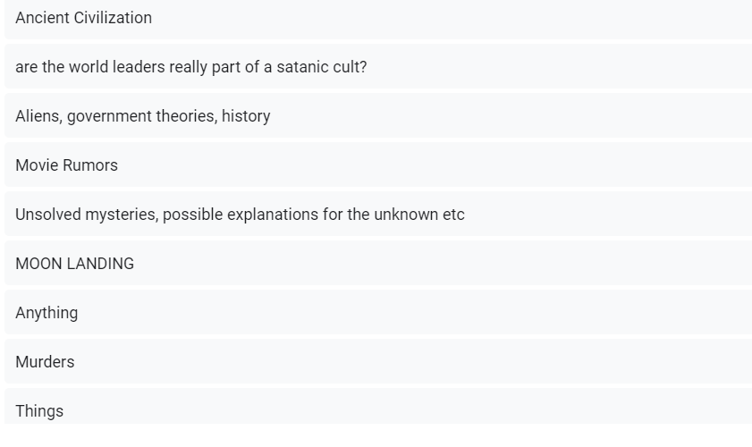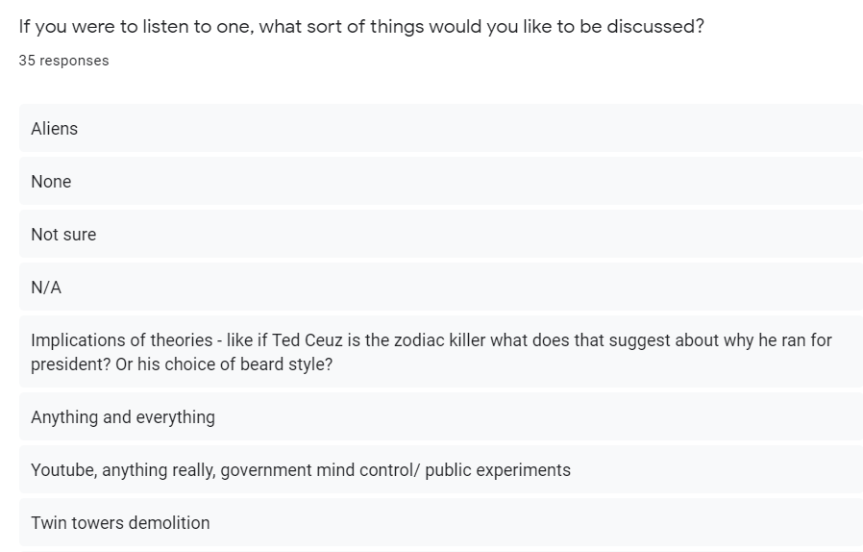By creating a question with such a broad amount of choices, we are allowing a variety of choices for the participants to choose from. This shows us about their preferences and the most popular choice.

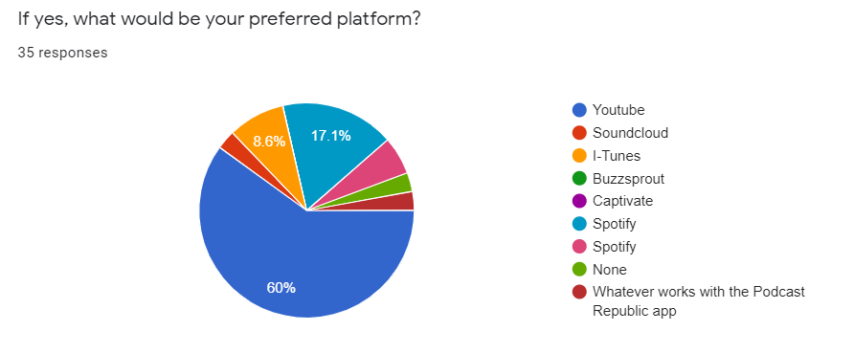The information gathered from this question shows the most popular streaming platform for podcasts. It is important to ask this question to understand what services are more convenient and used more frequently so we have a stronger idea on where to host our content.

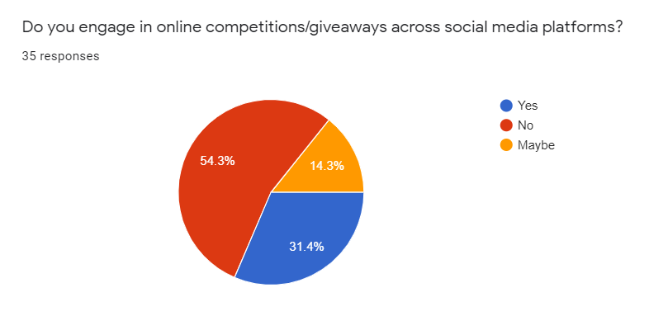

This shows us whether this is something that we could incorporate into the brand and whether it would be feasible to make this a recurring feature.

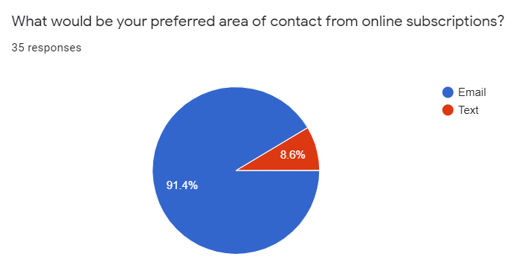

By including his question, we can see which method of contact is beneficial for the listeners and how they would prefer to manage these updates. Email seems to hold a large majority,

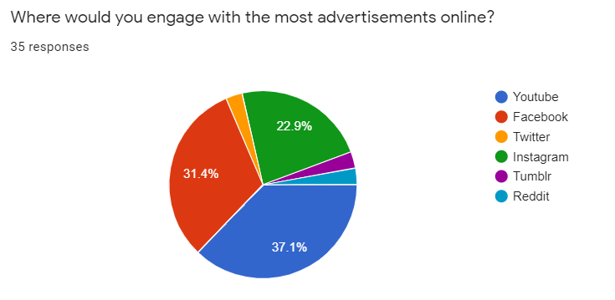

By this, we can see where best to market our advertisements to get the largest engagement. YouTube would be our main channel.

# Behavioural

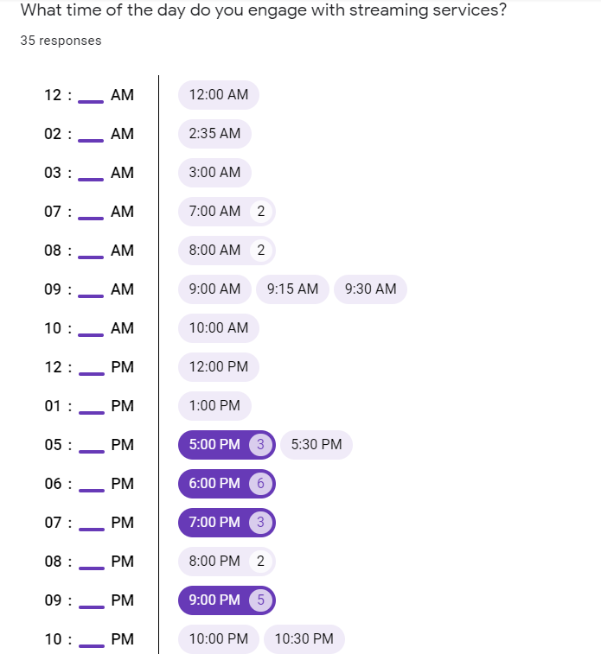By these three questions, we can see the hours and days with the largest streaming engagement, this will give us an idea on best hours to post content and stream our podcast.

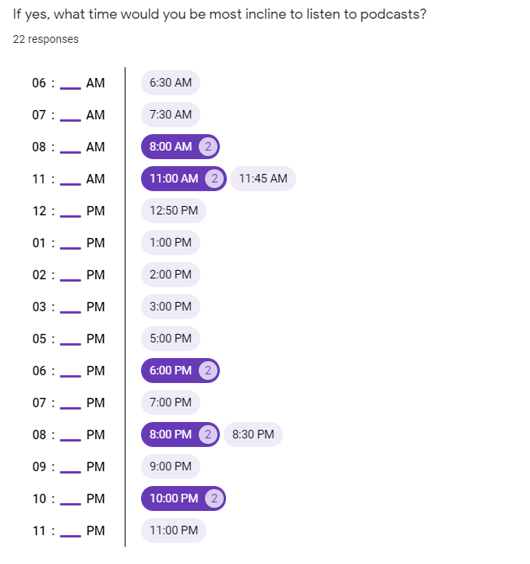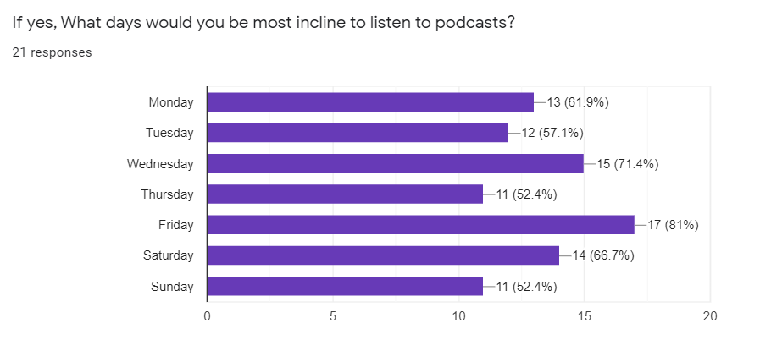

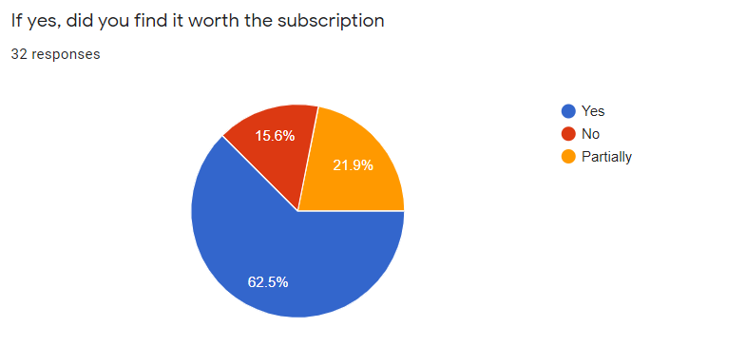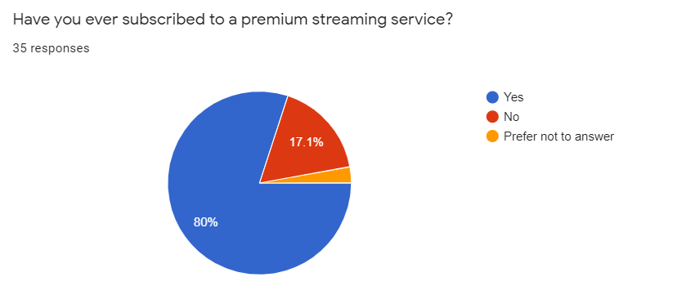These two questions regarding purchasing a premium service give us an idea if this would be worth marketing and if there would be enough engagement with the service to make it worthwhile. The results seem to show that it would be of interest to our customers.

# Digital/Online Marketing Campaign

## Goals and objectives

Our Market Campaign, is being planned and designed in order to spread the word about our business in the best possible light, but also without divulging any of the actual content so that we may draw in as many curious customers as possible and establish a wide, but loyal fan-base quickly.

## Developing our Image & brand

For the Campaign we have already researched an efficient and costly method of printing posters. The on company which we decided on (door2door) also distributes the leaflets throughout Ireland by the county. And posters can be put on display by staff members in key areas of our base town Waterford, and anywhere we happen to frequent as students such as Wexford, Dublin, and Cork.

We have also begun looking at producing and distributing merchandise such as the T-shirts below.

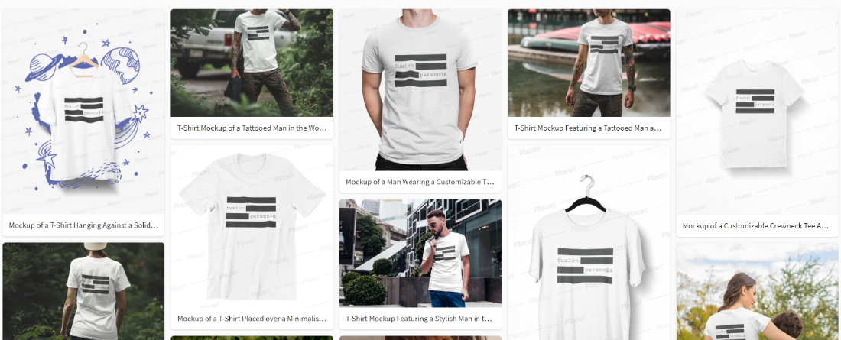

## Improvements on Website

We have been further developing our page by adding information pages about the company, for first time visitors. Samples of interesting conspiracy theories, that are open to change but also serve as great introductions to the community and enjoyment of this time of material.

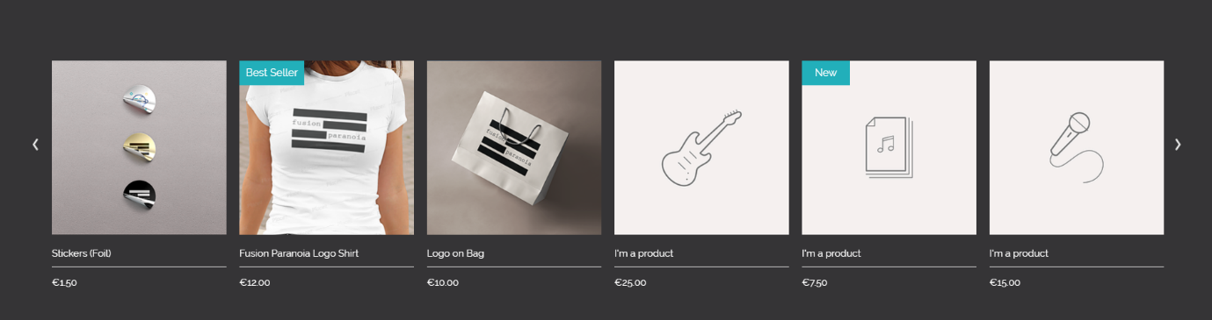And a section of links with sample images of some of our best products!

## Content

On our page is a variety of interesting and trending stories, that serve as a compelling introduction for anyone to read. This features sections which will be shown on a regular basis along with monthly popular sections such as:

The Missing, Murder & Mystery month 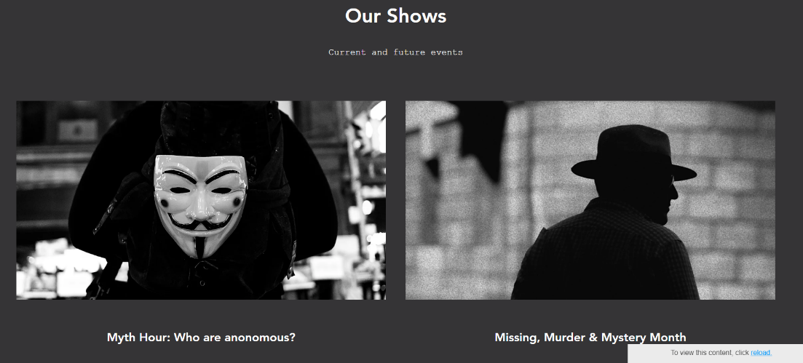in March

**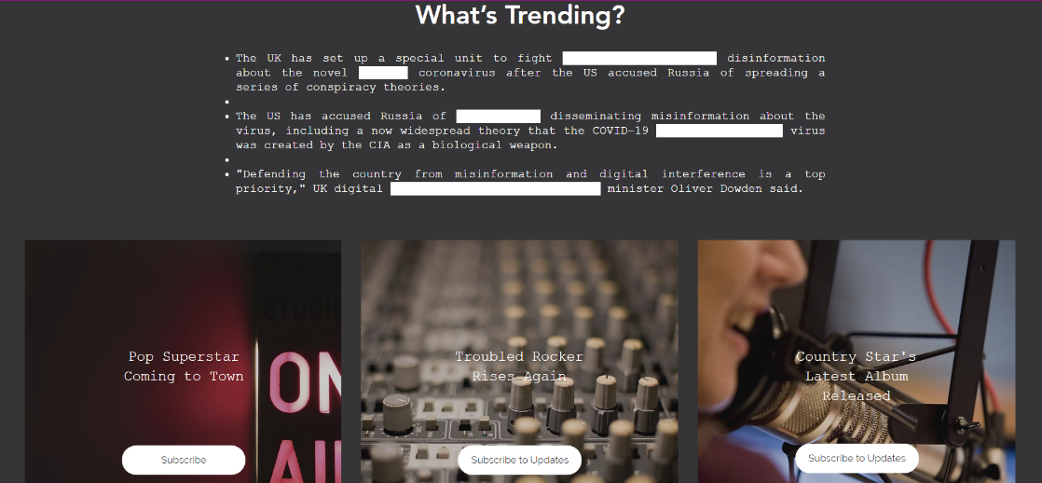Whats Trending?**

The section here shows usage of the design document which was developed for the project.

## Email marketing strategy

We have conducted research on what our customers’ desire, through the use of surveys and a phone in segment of the show every Saturday.

From conducting this marketing campaign we've been collecting a number of emails, from those interested in our content or who feel they have constructive suggestions for the show.  
 However, due to GDPR that information must be kept amongst the appropriate staff members and the participant. Especially as these were terms that had to be agreed upon during the survey’s terms and conditions section.

We also conducted research into how to conduct a successful E-mail marketing campaign.

* But we need to focus on those who’s search history matches the demographic
* Using a reply optional email means we come across as genuine and approachable
* Breakdown the E-mail list within the database into different segments to better tailor the Email to their desires.

We are currently considering the usage of a random E-mail generator in order to further promote our service amongst those who may otherwise be unreachable.

## Search Engine Optimisation.

Search Engine Optimisation is an evolving equation that grows more and more complex. However, one of the base parts of its function is looking for key words that repeat amongst the pages various elements. To work on our own SEO we shall use these amongst our different introduction pages on our website and social media pages. Key words such as, “Conspiracy”, “Truth”, “Happened”, “Hacking”, and “Believe”. We shall however avoid the use of words such as “government” as we do not wish to be involved in the questioning or upsetting of any political party while starting up a business.   
Should we need to we also plan on using a string of key words such as this and other randomly generated words in Text boxes and headers that shall be hidden, by either setting the opacity of the text to 100% or by placing said text in a miniscule font behind other elements of the page.

The use of links from the website to popular sites will also work to boost our website in google results, such as main social media sites and streaming services. However, this is a lesser factor to take into account and the inclusion of streaming services actually runs the risk of losing or at least distracting customers from our content and products.

The only other free option is to simply invite as many people as possible to the page and hope to generate traffic as that is also included in search engines criteria.

## Effectiveness of the Campaign

From analysis of the campaign that ran since the beginning of the CA, I believe we have covered a lot of basis and learned a lot about our target market and potential for further marketing growth. Based on survey results and answers we have found the majority of our groups to be males and that would buy apparel, time to stream/broadcast along with their activity.

I feel this information is extremely necessary in starting a company which is why the questions were so direct. Overall, I think the campaign was a success, and we hope to see for future basis the result and effect.

## Analysing the responses to the Marketing Campaign

Response analysis is the process of analysing response data to determine how well a direct marketing campaign actually performed. The four main platforms to spread awareness of our service are Facebook, Twitter, Instagram and YouTube. All merchandise on the static website is linked to all social media platforms.

YouTube**:** https://www.youtube.com/channel/UCiiEurAX6KApjEHk49Sn\_Nw?view\_as=subscriber

Twitter**:** <https://twitter.com/FusionParanoia1>

Instagram**:**

<https://www.instagram.com/fusionparanoia1/>

Facebook**:** <https://www.facebook.com/Fusion-Paranoia-110372460580668/?ref=aymt_homepage_panel&eid=ARBxv2_qShnaGNkcKFJ_uoUh6iJul8E5h0fa-4v7bQ7ozepdp4oPYa_XQDbxThPszU0GkO5MGAl4q6xc>

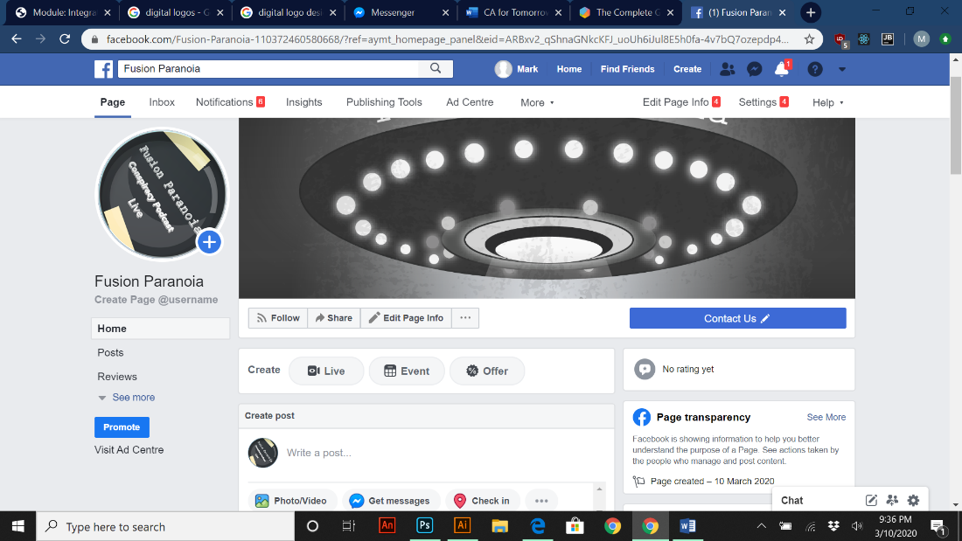

**Static Website:** <https://fusionparanoia.wixsite.com/iwanttobelieve>

In short the responses from the general public has been null so far due to the fact that these platforms have been opened recently.

## Measuring the effectiveness of the Campaign

Cost per head is a cost-effectiveness factor of marketing campaigns. This metric tends to focus entirely on the leads generated by the campaign. Cost per lead (CPL), is an online advertising pricing model, where the advertiser pays for a sign-up from a consumer interested in the advertisers offer.

Another way of measuring our progress for our own merchandise is measuring incremental sales which shows the effectiveness of your marketing campaigns in generating sales1 and are good at comparing marketing efforts. However, managing incremental sales is a case were our own company manages to make more than expected each month on selling our brand to consumers by paying more into advertising.

Using a well-known tool such as Google Analytics which measures and analyses the sales process for leads generated by a marketing campaign. This tool is great for finding drop off points of our sales from our own “Wix” website and for finding out more about the incoming traffic of the website or sales cycle.

Since our service is provided off YouTube for revenue along with the independent website for sales on merchandise that leads into separate marketing channels which can overlap. For example, a customer finds out about our brand/service on social media and returns to it via a search engine. This brings me to the point of Multi-Channel Funnels which shows all channels of traffic to the main website to which works in harmony to convert your visitors to customers.

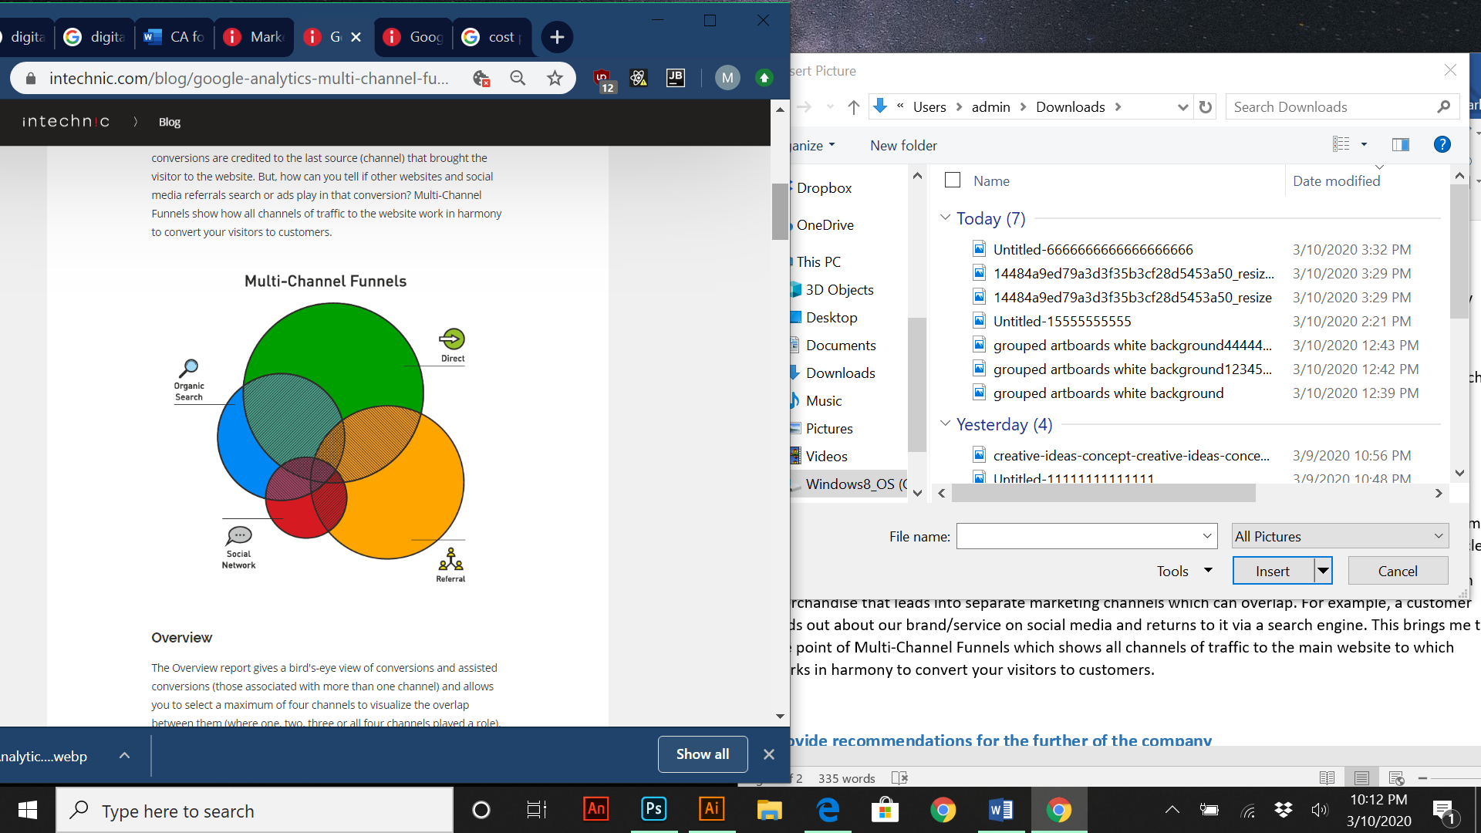

One last thing to mention is tracking user traffic via built analytics via our social media platforms (YouTube, Twitter, Facebook, and Instagram). The diagram above shows in brief the process of Multi-Channel Funnels.

## Provide recommendations for the further of the company

#### Google Ads:

An idea to start with would be incorporating advertisements on Google for all merchandise shown on our “Wix” website for t-shirts, mugs and badges. The reason for putting this type of advertising in place is that Google Ads are the majority of what people see when they search anything online and a good way to get consumer attention.

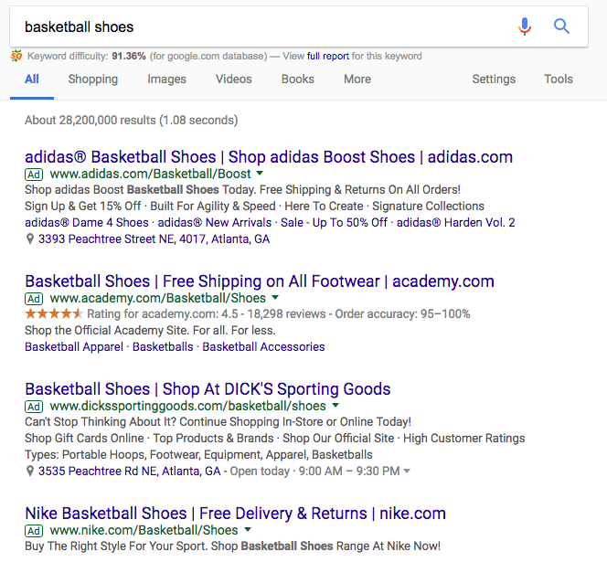

To the left is an example of Google advertising for products on top of any search results. The main factor to consider here is competing brands for the same keywords as the products were trying to sell online, Google will sometimes sort in order of relevance when this happens.

## Advertisement Congruence:

Ad congruence is when your ads and the landing page (our website) look alike and have the same message. For example, when a customer clicks on an ad for our products and the home page for our website looks nothing like the theme of our ads.

The big thing to take from this is keeping a consistent theme and message on all platforms so the customer feels like there in the right place. If all platforms are radically different from each other when there promoting the same products, the customer will become confused and exit entirely.

#### Utilize website pop-ups:

Although pop-ups aren’t necessarily good in high numbers, having website pop-ups allows us to collect information such as email addresses, from people who visit our site. A good way to entice people to follow up on these pop-ups is offer coupons or trials on products we offer by submitting their information such as their email address to continue to our site or buy products. Pop-ups are helpful because once setup, they do the rest of the work for you.

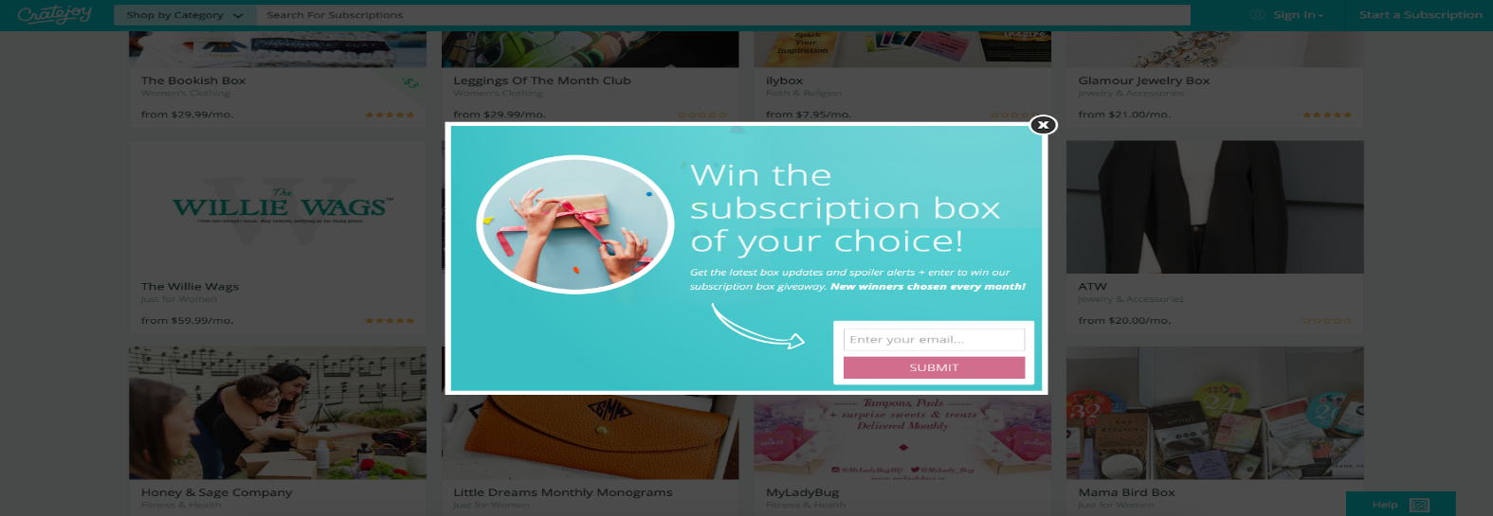

#### Boost Posts:

Getting reach from consumers on Facebook can be unpredictable. Facebook as a platform only shows content to a very small percentage of followers by default. Facebook is a pay to play platform. This means that in order for a larger audience to see our products, we have to pay for it.

Facebook has a boost feature that helps increase engagement and help promote products or services. It ensures that our content and services is in front of our audience.



# References

|  |  |
| --- | --- |
| [1] | S. MacDonald, “Email Marketing Strategy: A Data-driven Guide (with Original Case Studies),” superoffice, 10 March 2020. [Online]. Available: https://www.superoffice.com/blog/email-marketing-strategy/. [Accessed 9 March 2020]. |
| [2] | Triton & Edison Research, “edisonresearch,” 2019. [Online]. Available: https://www.edisonresearch.com/podcast-consumer-2018/. [Accessed 27 march 2019]. |
| [3] | C. theories, “Podbean,” 2019. [Online]. Available: https://www.podbean.com/podcast-detail/3xbjg-73fdc/Conspiracy-Theories-Podcast. [Accessed 29 March 2019]. |
| [4] | T. t. i. somewhere, “Podbean,” 2019. [Online]. Available: https://www.thetruthissomewhere.com/. [Accessed 29 March 2019]. |
| [5] | G. Rochford, “ThoseConspiracyGuys,” [Online]. Available: https://thoseconspiracyguys.com/. [Accessed 29 March 2019]. |
| [6] | A. Pratap, “Microenvironmental factors affecting business,” notesmatic, 11 January 2020. [Online]. Available: https://notesmatic.com/2017/07/microenvironmental-factors-affecting-business/. [Accessed 28 February 2020]. |
| [7] | Fusion Paranoia, “Facebook,” [Online]. Available: https://www.facebook.com/Fusion-Paranoia-110372460580668/. [Accessed 10 March 2020]. |
| [8] | Fusion Paranoia, “Youtube,” 5 March 2020. [Online]. Available: https://www.youtube.com/channel/UCiiEurAX6KApjEHk49Sn\_Nw. [Accessed 10 March 2020]. |